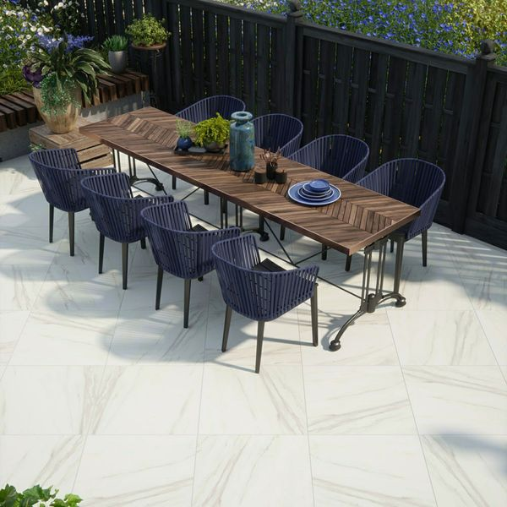**Calacatta Gold Porcelain:**

## **Product Description**

Introduce a touch of the Mediterranean to your outdoor spaces with these luxurious marble effect tiles. Calacatta Gold Slab Tiles are made from durable porcelain that's 20mm thick ensuring they can withstand the weather all year round. Inspired by natural Calacatta Gold, these tiles incorporate a realistic golden marble vein that draws on a lavish yet organic feel for external living areas.

Have you seen our [20mm Paving Slab Trims](https://www.wallsandfloors.co.uk/20mm-paving-slab-trims)?

**What's special about these tiles?**

> Luxury Marble Effect design

> Organic veining for soft, elegant style

> 20mm thick durable porcelain

> Long lasting and frostproof

> Perfect for a stylish patio space

**Take a closer look**

Want to take a closer look at these tiles before placing a full order? Why not order a sample tile? We send samples out with Free Delivery! They're the perfect way to see what a tile looks like in position in your home.

## **Product Info**

* Product ID: 44558
* Tiles Per SQM: 2.6874496103198
* Sale by: Per SQM
* Size: 610x610x20mm
* Weight: 16.50 KG
* Material Type: Porcelain
* Finish: Matt
* Colour: White
* Suitability: Floors
* Area Of Usage: External
* Grade: 5
* Rectified Edge: No
* Underfloor Heating: Yes
* Anti Slip Grade: R11 / 35 Degrees
* Document: [20mm Installation Guide](https://m2.wallsandfloors.co.uk/media/amasty/amfile/attach/20mm-installation-guide_4.pdf),[Cleaning and Protection Guide](https://m2.wallsandfloors.co.uk/media/amasty/amfile/attach/ltp_-_walls_floors_-_external_porcelain_-_cleaning_and_protection_guide_-_april_2020.pdf)
* Thickness (mm): 20